## CSC311 HOMEWORK 1

Xinyi Liu 1003792773

Q1.

(a)

$E\left(Z\right)= E\left({\left|X-Y\right|}^{2}\right)=E\left(X^{2}+Y^{2}-2XY\right)$

$=E\left(X^{2}\right)+E\left(Y^{2}\right)-2E\left(XY\right) by linearity of expectation$

$=Var\left(X\right)+E{\left(X\right)}^{2}+Var\left(Y\right)+E{\left(Y\right)}^{2}-2E\left(XY\right) since Var\left(X\right)=E\left(X^{2}\right)-E{\left(X\right)}^{2}$

$= Var\left(X\right)+E{\left(X\right)}^{2}+Var\left(Y\right)+E{\left(Y\right)}^{2}-2E\left(X\right)E\left(Y\right) since X,Y are independent$

Since X and Y are two independent univariate random variables sampled uniformly from the unit interval [0, 1], the expectation of X and Y is $E\left(X\right)=E\left(Y\right)=\frac{1}{2}, Var\left(X\right)=Var\left(Y\right)=\frac{1}{12}$

$$E\left(X^{2}\right)=E(Y^{2})=\int_{0}^{1}{x^{2}dx}=\frac{1}{3}$$

$$E\left(X^{3}\right)=E(Y^{3})=\int_{0}^{1}{x^{3}dx}=\frac{1}{4}$$

$$E\left(X^{4}\right)=E(Y^{4})=\int_{0}^{1}{x^{4}dx}=\frac{1}{5}$$

$E\left(Z\right)= Var\left(X\right)+E{\left(X\right)}^{2}+Var\left(Y\right)+E{\left(Y\right)}^{2}-2E\left(X\right)E\left(Y\right)$

$=\frac{1}{12}+\frac{1}{4}+\frac{1}{12}+\frac{1}{4}-2\frac{1}{4}$

$=\frac{1}{6}$

$Var\left(Z\right)= E\left(Z^{2}\right)-{E(Z)}^{2}$

$= E\left({\left(X-Y \right)}^{4}\right)-\frac{1}{6^{2}}$

$= E(X^{4} – 4X^{3}Y + 6X^{2}Y^{2} – 4{XY}^{3} + Y^{4})-\frac{1}{36}$

by linearity of expectation and the fact that X and Y are independent

$= E\left(X^{4}\right)-4E\left(X^{3}\right)E\left(Y\right)+6E\left(X^{2}\right)E\left(Y^{2}\right)-4E\left(X\right)E\left(Y^{3}\right)+E\left(Y^{4}\right)-\frac{1}{36}$

$= \frac{1}{5}-4*\frac{1}{4}*\frac{1}{2}+6*\frac{1}{3}*\frac{1}{3}-4*\frac{1}{2}*\frac{1}{4}+\frac{1}{5}-\frac{1}{36}$

$=\frac{7}{180}$

Therefore, the expectation of Z is $\frac{1}{6}$ and the variance of Z is $\frac{7}{180}$.

(b)

$E\left(R\right)= E\left(Z_{1}+Z_{2}+…+Z_{d}\right)$

$=E\left(Z_{1}\right)+E\left(Z_{2}\right)+…+E\left(Z_{d}\right)$

$= E\left({\left|X_{1}-Y_{1}\right|}^{2}\right)+E\left({\left|X_{2}-Y_{2}\right|}^{2}\right)+…+E\left({\left|X_{d}-Y_{d}\right|}^{2}\right)$

$Var\left(R\right)=Var\left(Z_{1}+Z_{2}+…+Z_{d}\right)$

$=Var\left(Z_{1}\right)+…+Var\left(Z_{d}\right)$

$= Var\left({\left|X_{1}-Y_{1}\right|}^{2}\right)+Var\left({\left|X_{2}-Y_{2}\right|}^{2}\right)+…+Var\left({\left|X_{d}-Y_{d}\right|}^{2}\right)$

Since all random variables $X_{1},…, X_{d}$ and $Y_{1},…, Y_{d}$ are independently and uniformly form [0, 1], using the answer from part (a), we get

$E\left(R\right)= E\left({\left|X_{1}-Y_{1}\right|}^{2}\right)+E\left({\left|X_{2}-Y_{2}\right|}^{2}\right)+…+E\left({\left|X_{d}-Y_{d}\right|}^{2}\right)$

$=dE\left(Z\right)$

$=\frac{d}{6}$

$Var\left(R\right)= Var\left({\left|X_{1}-Y_{1}\right|}^{2}\right)+Var\left({\left|X_{2}-Y_{2}\right|}^{2}\right)+…+Var\left({\left|X_{d}-Y_{d}\right|}^{2}\right)$

$=dVar\left(Z\right)$

$=\frac{7d}{180}$

(c)

Let MED be the maximum possible squared Euclidean distance between two points within the d-dimensional unit cube (i.e. the squared Euclidean distance between opposite corners of the cube (0, 0, …, 0) and (1, 1, …, 1)).

$$MED={\left(1-0\right)}^{2}+{\left(1-0\right)}^{2}+{\left(1-0\right)}^{2}+…+{\left(1-0\right)}^{2}=d$$

Compare $E\left(R\right)$, $SD\left(R\right)$ to MED, as dimension goes to infinity:

$$\lim_{d→∞}{E\left(R\right)}= \lim_{d→∞}{\frac{d}{6}}→ ∞$$

And the standard deviation relative to MED when dimension goes to infinity is

$$\lim_{d→∞}{\frac{\sqrt{Var(R)}}{d}}= \lim_{d→∞}{\sqrt{\frac{7}{180}}\frac{\sqrt{d}}{d} }→ 0$$

Therefore, in high dimensions, most points are far away, and approximately the same distance.

Q2.

(a)

Since p(x) is a probability mass function, $0≤p\left(x\right)≤1$.

Then $\frac{1}{p(x)}≥1$ and by the property of log function, $\log_{2}\left(\frac{1}{p\left(x\right)}\right)≥0$.

So $p\left(x\right)\log_{2}\left(\frac{1}{p\left(x\right)}\right)≥0$ for all possible x.

Since $H\left(X\right)= \sum_{x}{p\left(x\right)\log_{2}\left(\frac{1}{p\left(x\right)}\right)}$ where x is all possible values, $H\left(X\right)≥0$.

Hence H(X) is non-negative.

(b)

Since X, Y are independent random variables, p(x, y) = p(x)p(y)

Then

$H\left(X, Y\right) = \sum_{x}{\sum_{y}{p\left(x, y\right)\log_{2}\left(\frac{1}{p\left(x, y\right)}\right)}}$

$= \sum_{x}{\sum_{y}{p\left(x\right)p(y)\log_{2}\left(\frac{1}{p\left(x\right)p(y)}\right)}}$

$= \sum_{x}{\sum_{y}{p\left(x\right)p\left(y\right)\left(\log_{2}\left(\frac{1}{p\left(x\right)}\right)+\log_{2}\left(\frac{1}{p\left(y\right)}\right)\right) }}$

$= \sum_{x}{\sum_{y}{p\left(x\right)p\left(y\right)\log_{2}\left(\frac{1}{p\left(x\right)}\right) }}+\sum_{x}{\sum_{y}{p\left(x\right)p\left(y\right)\log_{2}\left(\frac{1}{p\left(y\right)}\right) }}$

$= \sum_{y}{p\left(y\right)\sum_{x}{p\left(x\right)\log_{2}\left(\frac{1}{p\left(x\right)}\right) }}+\sum_{x}{p\left(x\right)\sum_{y}{p\left(y\right)\log_{2}\left(\frac{1}{p\left(y\right)}\right) }}$

Since $\sum_{x}{p(x)}=p\left(χ\right)=1=\sum_{y}{p(y)}$

$= \sum_{x}{p\left(x\right)\log_{2}\left(\frac{1}{p\left(x\right)}\right) }+\sum_{y}{p\left(y\right)\log_{2}\left(\frac{1}{p\left(y\right)}\right) }$

$=H\left(X\right)+H\left(Y\right)$

(c)

By the definition of conditional entropy,

$$H\left(Y | X\right)= -\sum_{x}{\sum_{y}{p\left(x, y\right)\log_{2}{p\left(y | x\right)}}}= -\sum_{x}{\sum_{y}{p\left(x, y\right)\log_{2}{\frac{p(x, y)}{p(x)}}}}$$

$$= \sum_{x}{\sum_{y}{p\left(x, y\right)\log_{2}{{\left(\frac{p\left(x, y\right)}{p\left(x\right)}\right)}^{-1}}}}=\sum_{x}{\sum_{y}{p\left(x, y\right)\log_{2}\left(\frac{p\left(x\right)}{p\left(x, y\right)}\right)}}$$

$$=\sum_{x}{\sum_{y}{p\left(x, y\right)\log_{2}\left(p(x)\right)}}-\sum_{x}{\sum_{y}{p\left(x, y\right)\log_{2}\left(p\left(x, y\right)\right)}}$$

$$=\sum_{x}{p\left(x\right)\log_{2}\left(p(x)\right)}+\sum_{x}{\sum_{y}{p\left(x, y\right)\log_{2}\left(\frac{1}{p\left(x, y\right)}\right)}} since \sum_{y}{p\left(x, y\right)}=p(x)$$

$$=\sum_{x}{\sum_{y}{p\left(x, y\right)\log_{2}\left(\frac{1}{p\left(x, y\right)}\right)}}-\sum_{x}{p\left(x\right)\log_{2}\left(\frac{1}{p(x)}\right)}$$

$$=H\left(X, Y\right)-H(X)$$

Hence, $H\left(X, Y\right)=H\left(X\right)+H(Y|X)$

(d)

From the question, we know $KL(p||q) =\sum_{x}{p\left(x\right)\log_{2}{\frac{p\left(x\right)}{q\left(x\right)}}}=- \sum_{x}{p\left(x\right)\log_{2}{\frac{q\left(x\right)}{p\left(x\right)}}}$

To prove $KL(p|\left|q\right)≥0$,

we want to prove $\sum_{x}{p\left(x\right)\log_{2}{\frac{q\left(x\right)}{p\left(x\right)}}}≤0 so that - \sum_{x}{p\left(x\right)\log_{2}{\frac{q\left(x\right)}{p\left(x\right)}}}≥0$.

Since $-\log_{2}{ }$ is a concave function, using Jensen’s inequality $∅\left(E\left[X\right]\right)≤E[∅\left(X\right)]$, we get

$$-\sum_{x}{p\left(x\right)\log_{2}{\frac{q\left(x\right)}{p\left(x\right)}}}=\sum_{x}{p\left(x\right)\left(-\log_{2}{\frac{q\left(x\right)}{p\left(x\right)}}\right)}$$

$$=E_{X\sim p}\left[-\log_{2}{\frac{q\left(x\right)}{p\left(x\right)}}\right]≥-\log_{2}{E_{X\sim p}\left[\frac{q\left(x\right)}{p\left(x\right)}\right]}$$

$$= -\log_{2}{\sum_{x}{p\left(x\right)\frac{q\left(x\right)}{p\left(x\right)}}}=-\log_{2}{\sum_{x}{q(x)}}$$

Since q is a probability distribution, $\sum_{x}{q(x)}=1→ -\log_{2}{\sum_{x}{q(x)}}=0$

So $-\sum_{x}{p\left(x\right)\log_{2}{\frac{q\left(x\right)}{p\left(x\right)}}}≥-\log_{2}{\sum_{x}{q\left(x\right)}}=0$

Therefore $KL(p|\left|q\right)=- \sum_{x}{p\left(x\right)\log_{2}{\frac{q\left(x\right)}{p\left(x\right)}}}≥0$ i.e. $KL(p|\left|q\right)$ is non-negative.

(e)

By the definition of KL divergence,

$$KL(p(x, y)||p\left(x\right)p\left(y\right)) = \sum_{x}{\sum_{y}{p\left(x, y\right)\log_{2}{\frac{p\left(x, y\right)}{p\left(x\right)p\left(y\right)}}}}$$

By the definition of information gain and entropy

$$I\left(Y;X\right)=H\left(Y\right)-H\left(Y | X\right)= \sum_{y}{p\left(y\right)\log_{2}\left(\frac{1}{p\left(y\right)}\right)}+\sum_{x}{\sum_{y}{p\left(x, y\right)\log_{2}{\frac{p(x, y)}{p(x)}}}}$$

$$= \sum_{x}{\sum_{y}{p\left(x, y\right)\log_{2}\left(\frac{1}{p\left(y\right)}\right)}}+\sum_{x}{\sum_{y}{p\left(x, y\right)\log_{2}{\frac{p(x, y)}{p(x)}}}} since \sum_{x}{p\left(x, y\right)}=p(y)$$

$$= \sum_{x}{\sum_{y}{p\left(x, y\right)\log_{2}\left(\frac{p(x, y)}{p(x)p\left(y\right)}\right)}}$$

Hence,

$$I\left(Y;X\right)=KL(p(x, y)||p\left(x\right)p\left(y\right))$$

3.

(b)

Accuracy for depth 16 and criteria entropy : 0.7346938775510204

Accuracy for depth 32 and criteria entropy : 0.753061224489796

Accuracy for depth 64 and criteria entropy : 0.7510204081632653

Accuracy for depth 128 and criteria entropy : 0.7346938775510204

Accuracy for depth 256 and criteria entropy : 0.746938775510204

Accuracy for depth 16 and criteria gini : 0.7306122448979592

Accuracy for depth 32 and criteria gini : 0.736734693877551

Accuracy for depth 64 and criteria gini : 0.753061224489796

Accuracy for depth 128 and criteria gini : 0.7489795918367347

Accuracy for depth 256 and criteria gini : 0.7448979591836735

(c)

Accuracy of the best hyperparameter on the test dataset: 0.746938775510204

Plot of the tree:

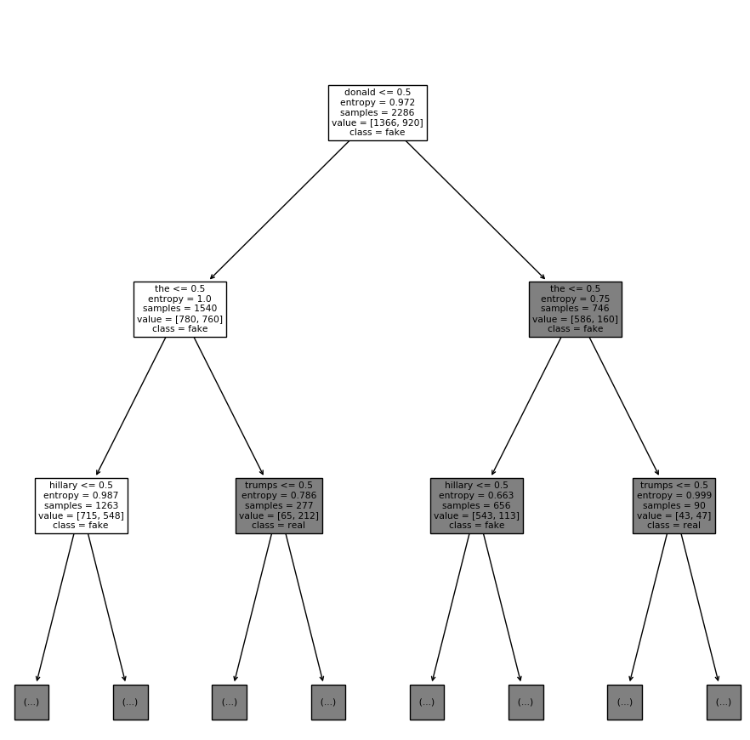

(d)

The information gain of 'donald': 0.05404605736121895

The information gain of 'trumps': 0.04240472003947697

The information gain of 'china': 0.0031134148983391124

The information gain of 'good': 0.0004942945179704354

(e)

The relationship between number of nearest neighbours and test error

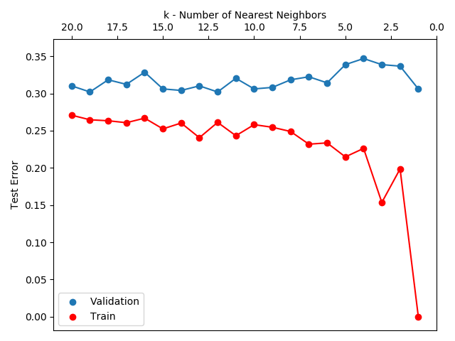

Accuracy of the best KNN model on the test dataset: 0.6551020408163265